Robert Kristian Alm
Movant 20/03/2017

6e (VLANs and Trunks for Beginners - Part 5)

Link for the video: https://www.youtube.com/watch?v=w6hfg4jQqDM

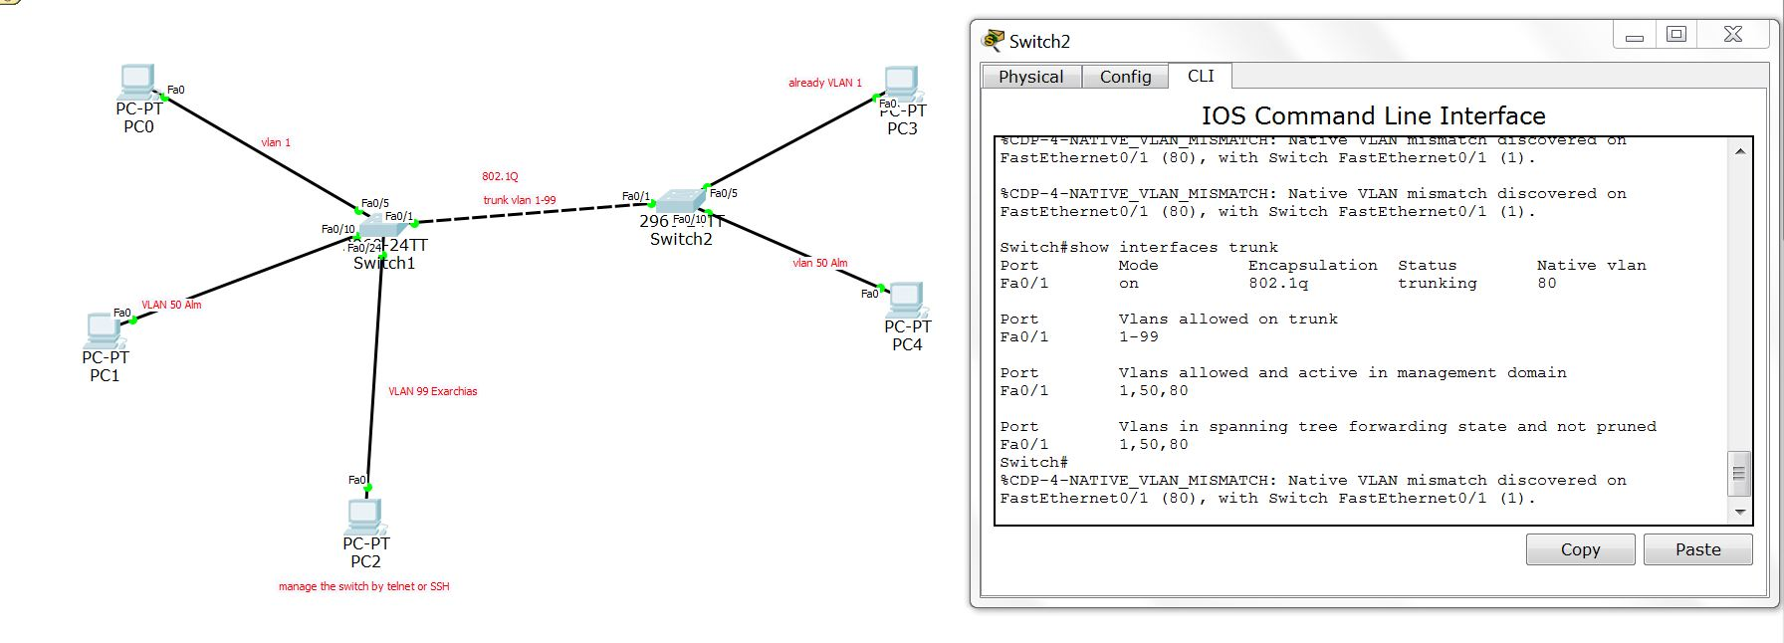

On the last part of the assignment we had to do for the native vlans. And that explains a bit why we had so much theory on the previous video. When we are on trunk mode. The frames between the switches are send encapsulated according to the encapsulation of 802.1Q protocol.

When the trunk switch receives frames that are not belong to the 802.1Q then the switch sends those frames to the default vlan1. Native vlan is a vlan which is dedicated to accept frames that are not belong to the 802.1Q. To use this VLAN as it is expected we have to activate it.

The activation is not something difficult. Just we have to assign a native vlan on all the switches that are working on trunk mode. The necessary commands are following below:

On the first conf t, (to creat the vlan):
vlan 80
name native

and on a new conf t, (yo assign the vlan to the necessary port):
int fa0/1
switchport trunk native vlan 80

On this point I should point out that most of switches are having/using advanced protocols that are detecting changes on vlans and hey are able as well to configure their vlan as well if they automatically if they are configured to do so.

